**Log in**  
-username & password + otp  
-phone number + otp

**Register**  
-username, email id, mobile no., password and confirmation of it.

**Dashboard**  
-**Business Details**  
**-Importer exporter CODE (IEC)**: a key business identification number which mandatory for export from India or Import to India. No export or import shall be made by any person without obtaining an IEC unless specifically exempted.  
   
**-AD CODE**: The AD code is an abbreviation for Authorised Dealer Code. It is a 14-digit code which is obtained from the bank where the dealer has its current account. It is one of the primary documents that dealers require to get through the customs clearance process after import-export registration.

**-GST NO.  
  
-LUT/BOND NO. :** LUT, an acronym for Letter of Undertaking holds significant relevance within the context of the Goods and Services Tax (GST) framework. This document serves as a powerful tool for exporters, allowing them to engage in the export of goods or services without the obligation of immediate tax payment.

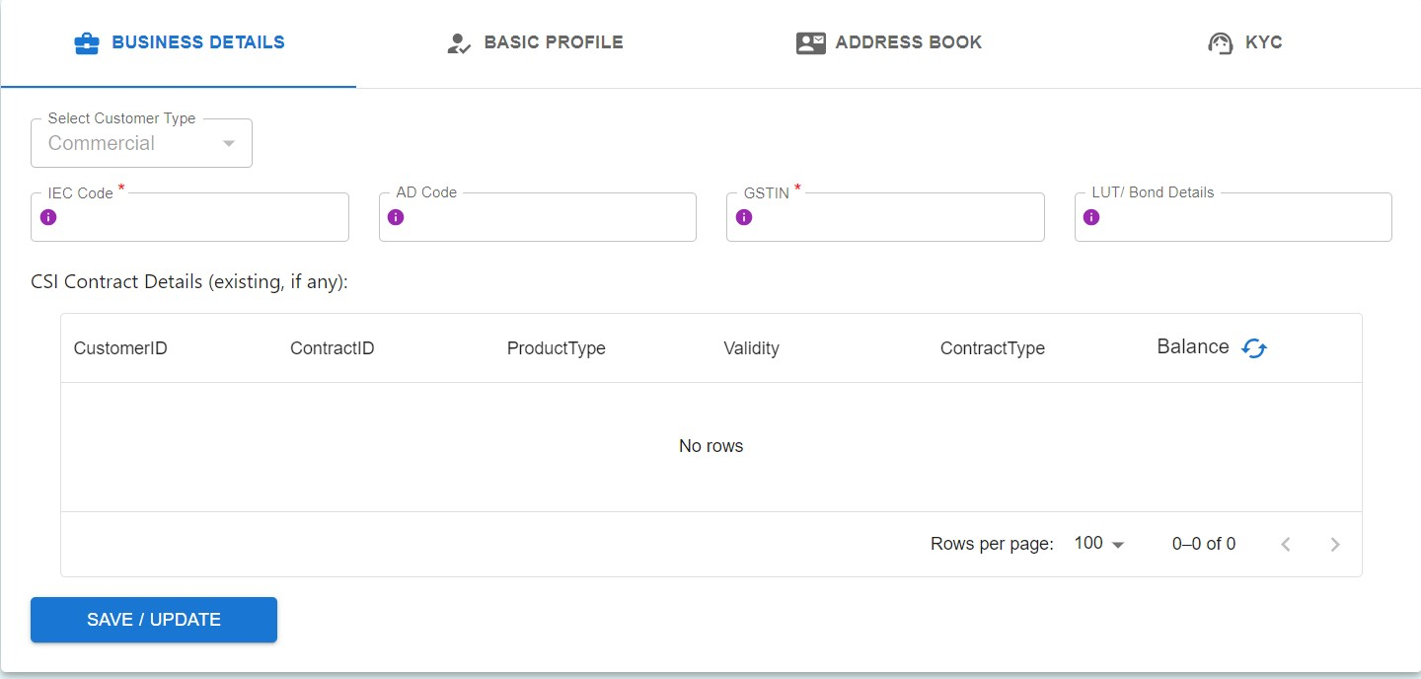

**-KYC:**

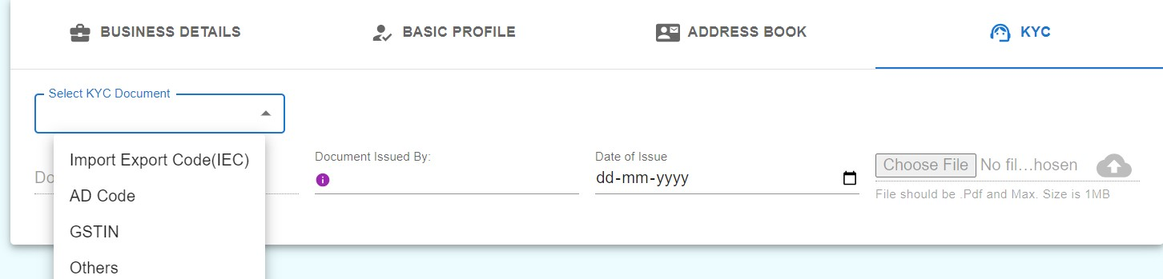

**Uploading all the documents required.**

**-Basic Profile:**all the basic details to be filled.

**-Address Book**

**To book the Shipment:**-go to “article booking” from MENU.  
-option to check availability of services(gives various services along with weight constraints) for the country where the order has been received from, “service available” in green is shown if services are available.  
-tariff calculator option  
-prohibited and restricted items list available to download

**\*you can also bulk upload multiple shipment details\***

**once “book article” is pressed, the “consignment details” page appears where all the details of the consignment are to be entered.**details to be filled:  
-select product  
-category of item  
-no. of items in consignment  
-gross weight  
-total value  
-instructions in case of non delivery(abandon, return on priority/non priority)  
-no. of licenses/invoices/certificates  
-select PBE(e-commerce or non e-commerce)  
-IEC code, AD code, GST code by default are also reflected  
-Self Filing option(y/n)  
  
**with “next”**-sender details are automatically reflected  
-receiver details are to be filled

**with “next”**piece details page appears  
-product details  
-details of parcels  
-value under section 14 customs act  
-custom duties  
-tax/commercial invoice  
-gst details  
-ecommerce particulars

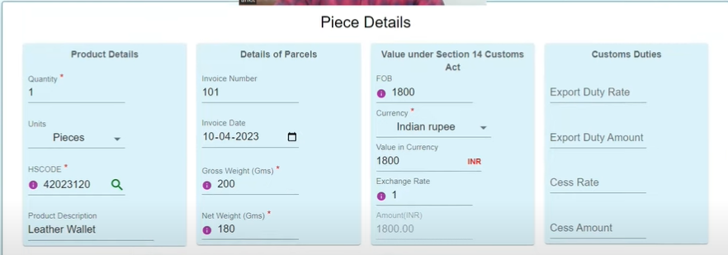

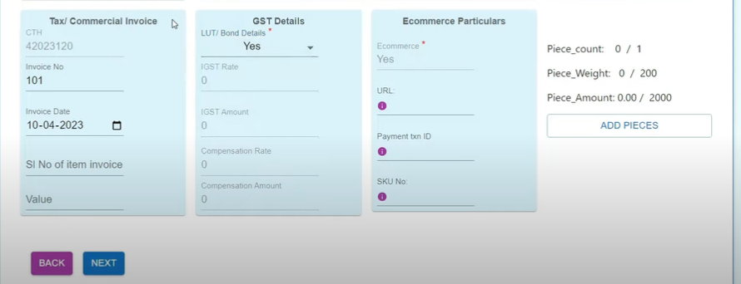

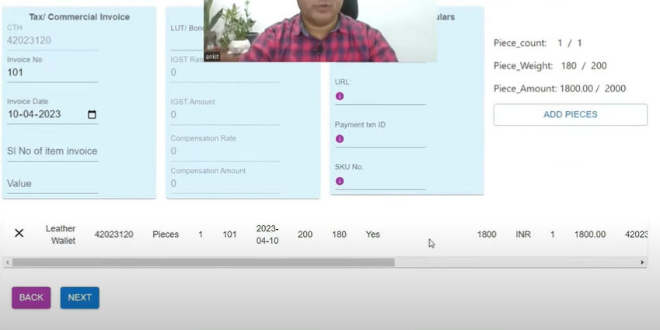

**With “next”**  
“declarations page” appears  
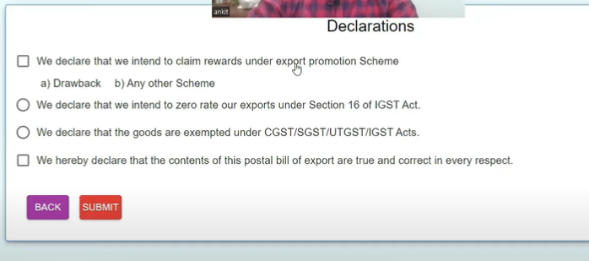

**with “submit”**  
process of article booking is completed and a pop up appears with IDs generated  
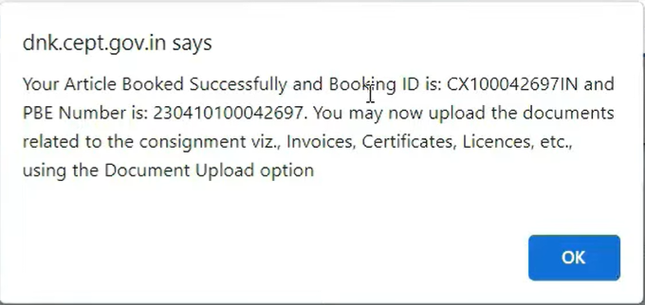

CN23 form is generated which is to be printed and affix lable is available. PBE can only be downloaded after custom clearance through article number from CN23 from the “forms download” option in MENU.

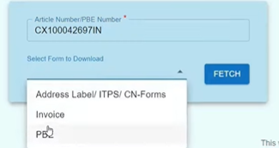

These forms are to be taken along with the shipment to nearby post office for further formalitites.